FILE SECURITY SYSTEM USING CRYPTOGRAPHY

ABSTRACT

The project “FILE SECURITY SYSTEM USING CRYPTOGRAPHY” is designed using Microsoft Visual Studio.Net 2008 as front end, which works in .Net framework version 3.5. The coding language used is Visual Basic .Net and Back End Sql Server 2005.

The project aims at securing the important documents by collecting them into one project file with or without encrypting all files. During the project file creation. Files are added, password entry made to individual files and any/all files can be encrypted using Triple DES encryption mechanism and stored as single project file. The project may also be password protected. Anytime the archive can be viewed, edited i.e., file addition, removal is done.

If all files are not password protected, then all files may get extracted at one time; otherwise we can extract one by one. If the file is password protected, then it is extracted after password submission. Thus the project aims in protecting the files and avoid unauthorized access.

INTRODUCTION
The project aims at protecting a single files or group of files in a system. All type of files can be protected using this project. First the user should select the files and give the password for the files to be protected. Files can also be encrypted using Triple DES Algorithm to prevent unauthorized access. After selecting the password, a project file is created. To extract the project, the project file should be opened and the password should be given for files to be extracted.

If we want to add any new files to the project, then add project option can be used to add new files to the existing project. This will erase the old project and creates a new project with updated information. Password protection can be applied to single files or multiple of files. If there is no password for any files, then extract all option can be performed to extract all the files to the specified folder.

Existing system:

In companies, the documents or other resources need to be protected and unauthorized persons must not access i.e., view or edit the documents. The documents if misused by others may cause the theft of the valuable data between the companies. Moreover, the document if splited in various partitions needs to be search so that they can be found out and collectively used. In addition, in normal desktop applications the files in partitions other than (New Technology File System)NTFS file system nay not be protected. Any user if the path is known can access the resources. Hence if a system such that combining the industry secure documents, password protecting and encrypting them is available, then they can be secured from theft. Hence the new system is being designed to achieve the result

Limitations of the existing system:
- It is not possible to set password all kind of files.
- Encryption and decryption is not possible
- Requires huge manpower.
- Preventing data loss is too difficult.
- Required output is not possible.
- all files are not password protected

Proposed system:
The new system i.e., the software developed is capable of adding the document or other files, may or may not password protected individually, either encrypted or not and collectively written as a project file. Even the project file is password protected if necessary so that other users can not open the project in this application. After archiving them to single file, it can be viewed and extracted either individual or all files. If none of the file is password protected, they can be extracted whole otherwise it is must to provide password to extract a particular file. The file is encrypted through the Triple DES (Data Encryption Standard Algorithm for safety. The Dotnet System.Security.Cryptography namespace is used for encryption and structure, file handling concepts are used for archiving the project. Since the project is created and edited as binary, the content may not be viewed in text editors easily.

Advantages:
- In the proposed system all the drawbacks of the existing system are carefully analyzed and all the pitfalls are resolved in an effective and efficient manner.
- The Proposed System has been made with better user interactive screens. The system is much user friendly and the end user will find it easy to do operations.
- Encryption and decryption is possible
Protect all file in the folder

Module Description

File Security System is divided into six modules

- Authentication
- Accumulation of Files
- Security Module
- Encrypt Data
- File Format Conversion
- Extracting Files

Authentication

In this module the authorized person only can enter in this security process. The data are stored in a database for the user verification.

Accumulation of Files

In this module, the files are accumulated for the privacy of data. We can add single files or multiple files to the project. Files can also be included later after creating the project. In this case, the old projects file will be deleted and the new project file will be created when including some files to your project list.
When adding single or multiple files, password can be given to each file to protect the access of unknown users from viewing the file. Any type of files can be added to the project by selecting the files.

Security Module:

Security Module is implemented using two ways in this project. First way is to provide security to single files or multiple files by specifying the password for each file. The second way is to provide security to the whole project by encrypting all the project files using Triple DES Algorithm. Encryption can be enabled or disabled for the particular project by enabling or disabling the encryption option for the project. When encrypting the project, the filename extension is changed into a new extension and saved.
The contents of the file are also encrypted so the unknown users can’t access the file. If anybody needs to open the project file, then he needs to know the authenticated information such as password for each file to be accessed. And the project application cannot be opened in any other application after encrypting the project.

Encrypt Data:

This module is used to display the encrypted files to the user. All the information about the projects is stored in the header information and all the details about the files are stored in the file header. The Encrypted project file can be opened only if the password is known and can be viewed only in the File protector application. After supplying the correct password, the protected files are listed in the project list window.
Here, the user can add new files to the project or delete existing files from the project. The files are displayed by reading project header information and file header information from the project file.

File Format conversion

The file format is converted to some other format. So the attacker cannot find the original format of a source file. For example the text file is ends with extension as .txt. So the hacker can easily find the format of a source. In our system the extension is to be changes as some other formats like .ccs etc.,

Extracting Data:

Extracting data module is used to extract files from the project window to the specified location. If the file is protected using password, then the exact password should be supplied to the password input window. After providing the correct password, the files are extracted into the specified folder. If the files are not password protected, then single files or multiple files can be extracted at the same time using the extract all option available under the project menu.

SYSTEM REQUIRMENT

Hardware Requirements
- SYSTEM : I3
- HARD DISK : 500 GB
- MONITOR : 15 LED colour
- MOUSE : Logitech.
- RAM : 4GB
- KEYBOARD : 110 keys enhanced.

Software Requirements
- Operating system :- Windows 10
- Front End :- VB.net
- Back End :- Sql server

SOFTWARE SPECIFICATION

What is .NET?
When .NET was announced in late 1999, Microsoft positioned the technology as a platform for building and consuming Extensible Markup Language (XML) Web services. XML Web services allow any type of application, be it a Windows- or browser-based application running on any type of computer system, to consume data from any type of server over the Internet. The reason this idea is so great is the way in which the XML messages are transferred: over established standard protocols that exist today. Using protocols such as SOAP, HTTP, and SMTP, XML Web services make it possible to expose data over the wire with little or no modifications to your existing code.
Figure 1.1 presents a high-level overview of the .NET Framework and how XML Web services are positioned.

Figure 1.1. Stateless XML Web services model.
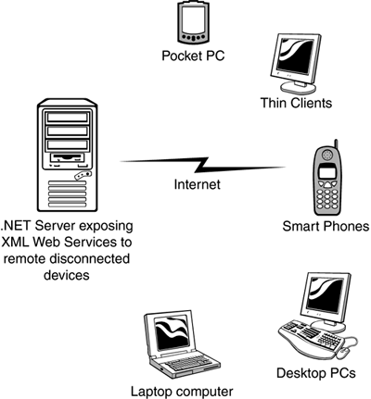
Since the initial announcement of the .NET Framework, it's taken on many new and different meanings to different people. To a developer, .NET means a great environment for creating robust distributed applications. To an IT manager, .NET means simpler deployment of applications to end users, tighter security, and simpler management. To a CTO or CIO, .NET means happier developers using state-of-the-art development technologies and a smaller bottom line. To understand why all these statements are true, you need to get a grip on what the .NET Framework consists of, and how it's truly a revolutionary step forward for application architecture, development, and deployment.

NET Framework
Now that you are familiar with the major goals of the .NET Framework, let's briefly examine its architecture. As you can see in Figure 1-2, the .NET Framework sits on top of the operating system, which can be a few different flavors of Windows and consists of a number of components .NET is essentially a system application that runs on Windows.
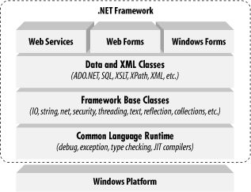

Conceptually, the CLR and the JVM are similar in that they are both runtime infrastructures that abstract the underlying platform differences. However, while the JVM officially supports only the Java language, the CLR supports any language that can be represented in its Common Intermediate Language (CIL). The JVM executes bytecode, so it can, in principle, support many languages, too. Unlike Java's bytecode, though, CIL is never interpreted. Another conceptual difference between the two infrastructures is that Java code runs on any platform with a JVM, whereas .NET code runs only on platforms that support the CLR. In April, 2003, the International Organization for Standardization and the International Electrotechnical Committee (ISO/IEC) recognized a functional subset of the CLR, known as the Common Language Interface (CLI), as an international standard. This development, initiated by Microsoft and developed by ECMA International, a European standards organization, opens the way for third parties to implement their own versions of the CLR on other platforms, such as Linux or Mac OS X. For information on third-party and open source projects working to implement the ISO/IEC CLI and C# specifications
The layer on top of the CLR is a set of framework base classes. This set of classes is similar to the set of classes found in STL, MFC, ATL, or Java. These classes support rudimentary input and output functionality, string manipulation, security management, network communications, thread management, text management, reflection functionality, collections functionality, as well as other functions.
On top of the framework base classes is a set of classes that extend the base classes to support data management and XML manipulation. These classes, called ADO.NET, support persistent data management—data that is stored on backend databases. Alongside the data classes, the .NET Framework supports a number of classes to let you manipulate XML data and perform XML searching and XML translations.
Classes in three different technologies (including web services, Web Forms, and Windows Forms) extend the framework base classes and the data and XML classes. Web services include a number of classes that support the development of lightweight distributed components, which work even in the face of firewalls and NAT software. These components support plug-and-play across the Internet, because web services employ standard HTTP and SOAP.
Web Forms, the key technology behind ASP.NET, include a number of classes that allow you to rapidly develop web Graphical User Interface (GUI) applications. If you're currently developing web applications with Visual Interdev, you can think of Web Forms as a facility that allows you to develop web GUIs using the same drag-and-drop approach as if you were developing the GUIs in Visual Basic. Simply drag-and-drop controls onto your Web Form, double-click on a control, and write the code to respond to the associated event.
Windows Forms support a set of classes that allow you to develop native Windows GUI applications. You can think of these classes collectively as a much better version of the MFC in C++ because they support easier and more powerful GUI development and provide a common, consistent interface that can be used in all languages.

The Common Language Runtime
At the heart of the .NET Framework is the common language runtime. The common language runtime is responsible for providing the execution environment that code written in a .NET language runs under. The common language runtime can be compared to the Visual Basic 6 runtime, except that the common language runtime is designed to handle all .NET languages, not just one, as the Visual Basic 6 runtime did for Visual Basic 6. The following list describes some of the benefits the common language runtime gives you:
- Automatic memory management
- Cross-language debugging
- Cross-language exception handling
- Full support for component versioning
- Access to legacy COM components
- XCOPY deployment
- Robust security model
You might expect all those features, but this has never been possible using Microsoft development tools. Figure 1.3 shows where the common language runtime fits into the .NET Framework.

Figure 1.3. The common language runtime and the .NET Framework.
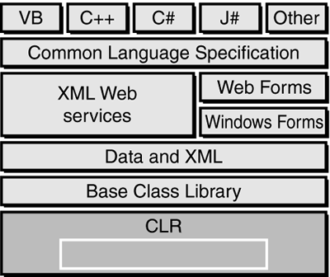

Note
Code written using a .NET language is known as managed code. Code that uses anything but the common language runtime is known as unmanaged code. The common language runtime provides a managed execution environment for .NET code, whereas the individual runtimes of non-.NET languages provide an unmanaged execution environment.

Inside the Common Language Runtime
The common language runtime enables code running in its execution environment to have features such as security, versioning, memory management and exception handling because of the way .NET code actually executes. When you compiled Visual Basic 6 forms applications, you had the ability to compile down to native node or p-code. Figure 1.4 should refresh your memory of what the Visual Basic 6 options dialog looked like.
Figure 1.4. Visual Basic 6 compiler options dialog.
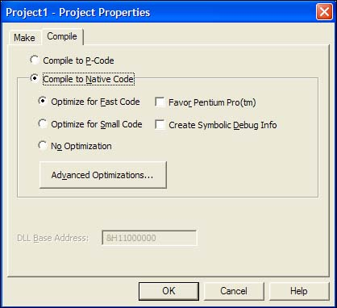
When you compile your applications in .NET, you aren't creating anything in native code. When you compile in .NET, you're converting your code—no matter what .NET language you're using—into an assembly made up of an intermediate language called Microsoft Intermediate Language (MSIL or just IL, for short). The IL contains all the information about your application, including methods, properties, events, types, exceptions, security objects, and so on, and it also includes metadata about what types in your code can or cannot be exposed to other applications. This was called a type library in Visual Basic 6 or an IDL (interface definition language) file in C++. In .NET, it's simply the metadata that the IL contains about your assembly.

Note
The file format for the IL is known as PE (portable executable) format, which is a standard format for processor-specific execution.

When a user or another component executes your code, a process occurs called just-in-time (JIT) compilation, and it's at this point that the IL is converted into the specific machine language of the processor it's executing on. This makes it very easy to port a .NET application to any type of operating system on any type of processor because the IL is simply waiting to be consumed by a JIT compiler.

Note
The first time an assembly is called in .NET, the JIT process occurs. Subsequent calls don't re-JIT the IL; the previously JITted IL remains in cache and is used over and over again. when you learn about Application Center Test, you also see how the warm-up time of the JIT process can affect application performance.

Understanding the process of compilation in .NET is very important because it makes clear how features such as cross-language debugging and exception handling are possible. You're not actually compiling to any machine-specific code—you're simply compiling down to an intermediate language that's the same for all .NET languages. The IL produced by J# .NET and C# looks just like the IL created by the Visual Basic .NET compiler. These instructions are the same, only how you type them in Visual Studio .NET is different, and the power of the common language runtime is apparent.
When the IL code is JITted into machine-specific language, it does so on an as-needed basis. If your assembly is 10MB and the user is only using a fraction of that 10MB, only the required IL and its dependencies are compiled to machine language. This makes for a very efficient execution process. But during this execution, how does the common language runtime make sure that the IL is correct? Because the compiler for each language creates its own IL, there must be a process that makes sure what's compiling won't corrupt the system. The process that validates the IL is known as verification. Figure 1.5 demonstrates the process the IL goes through before the code actually executes.

Figure 1.5. The JIT process and verification.

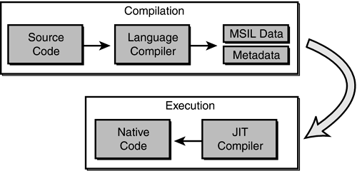
When code is JIT compiled, the common language runtime checks to make sure that the IL is correct. The rules that the common language runtime uses for verification are set forth in the Common Language Specification (CLS) and the Common Type System (CTS).

The .NET Framework Class Library
The second most important piece of the .NET Framework is the .NET Framework class library (FCL). As you've seen, the common language runtime handles the dirty work of actually running the code you write. But to write the code, you need a foundation of available classes to access the resources of the operating system, database server, or file server. The FCL is made up of a hierarchy of namespaces that expose classes, structures, interfaces, enumerations, and delegates that give you access to these resources.
The namespaces are logically defined by functionality. For example, the System.Data namespace contains all the functionality available to accessing databases. This namespace is further broken down into System.Data.SqlClient, which exposes functionality specific to SQL Server, and System.Data.OleDb, which exposes specific functionality for accessing OLEDB data sources. The bounds of a namespace aren't necessarily defined by specific assemblies within the FCL; rather, they're focused on functionality and logical grouping. In total, there are more than 20,000 classes in the FCL, all logically grouped in a hierarchical manner. Figure 1.8 shows where the FCL fits into the .NET Framework and the logical grouping of namespaces.

Figure 1.8. The .NET Framework class library.

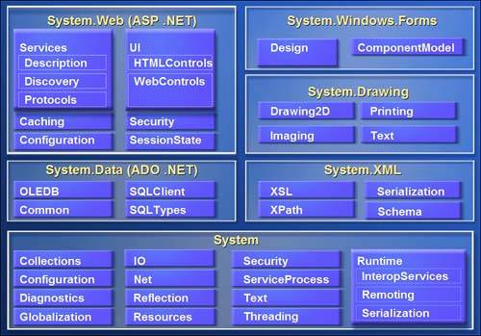
To use an FCL class in your application, you use the Imports statement in Visual Basic .NET or the using statement in C#. When you reference a namespace in Visual Basic .NET or C#, you also get the convenience of auto-complete and auto-list members when you access the objects' types using Visual Studio .NET. This makes it very easy to determine what types are available for each class in the namespace you're using. As you'll see over the next several weeks, it's very easy to start coding in Visual Studio .NET.
The Structure of a .NET Application
To understand how the common language runtime manages code execution, you must examine the structure of a .NET application. The primary unit of a .NET application is the assembly. An assembly is a self-describing collection of code, resources, and metadata. The assembly manifest contains information about what is contained within the assembly. The assembly manifest provides:
- Identity information, such as the assembly’s name and version number
- A list of all types exposed by the assembly
- A list of other assemblies required by the assembly
- A list of code access security instructions, including permissions required by the assembly and permissions to be denied the assembly
Each assembly has one and only one assembly manifest, and it contains all the description information for the assembly. However, the assembly manifest can be contained in its own file or within one of the assembly’s modules.
An assembly contains one or more modules. A module contains the code that makes up your application or library, and it contains metadata that describes that code. When you compile a project into an assembly, your code is converted from high-level code to IL. Because all managed code is first converted to IL code, applications written in different languages can easily interact. For example, one developer might write an application in Visual C# that accesses a DLL in Visual Basic .NET. Both resources will be converted to IL modules before being executed, thus avoiding any language-incompatibility issues.
Each module also contains a number of types. Types are templates that describe a set of data encapsulation and functionality. There are two kinds of types: reference types (classes) and value types (structures). These types are discussed in greater detail in Lesson 2 of this chapter. Each type is described to the common language runtime in the assembly manifest. A type can contain fields, properties, and methods, each of which should be related to a common functionality. For example, you might have a class that represents a bank account. It contains fields, properties, and methods related to the functions needed to implement a bank account. A field represents storage of a particular type of data. One field might store the name of an account holder, for example. Properties are similar to fields, but properties usually provide some kind of validation when data is set or retrieved. You might have a property that represents an account balance. When an attempt is made to change the value, the property can check to see if the attempted change is greater than a predetermined limit. If the value is greater than the limit, the property does not allow the change. Methods represent behavior, such as actions taken on data stored within the class or changes to the user interface. Continuing with the bank account example, you might have a Transfer method that transfers a balance from a checking account to a savings account, or an Alert method that warns users when their balances fall below a predetermined level.
Compilation and Execution of a .NET Application
When you compile a .NET application, it is not compiled to binary machine code; rather, it is converted to IL. This is the form that your deployed application takes—one or more assemblies consisting of executable files and DLL files in IL form. At least one of these assemblies will contain an executable file that has been designated as the entry point for the application.
When execution of your program begins, the first assembly is loaded into memory. At this point, the common language runtime examines the assembly manifest and determines the requirements to run the program. It examines security permissions requested by the assembly and compares them with the system’s security policy. If the system’s security policy does not allow the requested permissions, the application will not run. If the application passes the system’s security policy, the common language runtime executes the code. It creates a process for the application to run in and begins application execution. When execution starts, the first bit of code that needs to be executed is loaded into memory and compiled into native binary code from IL by the common language runtime’s Just-In-Time (JIT) compiler. Once compiled, the code is executed and stored in memory as native code. Thus, each portion of code is compiled only once when an application executes. Whenever program execution branches to code that has not yet run, the JIT compiler compiles it ahead of execution and stores it in memory as binary code. This way, application performance is maximized because only the parts of a program that are executed are compiled.
The .NET Framework base class library contains the base classes that provide many of the services and objects you need when writing your applications. The class library is organized into namespaces. A namespace is a logical grouping of types that perform related functions. For example, the System.Windows.Forms namespace contains all the types that make up Windows forms and the controls used in those forms.
Namespaces are logical groupings of related classes. The namespaces in the .NET base class library are organized hierarchically. The root of the .NET Framework is the System namespace. Other namespaces can be accessed with the period operator. A typical namespace construction appears as follows:
System
System.Data
System.Data.SQLClient
The first example refers to the System namespace. The second refers to the System.Data namespace. The third example refers to the System.Data.SQLClient namespace. Table 1.1 introduces some of the more commonly used .NET base class namespaces.
Table 1-1. Representative .NET Namespaces
Namespace | Description
System | This namespace is the root for many of the low-level types required by the .NET Framework. It is the root for primitive data types as well, and it is the root for all the other namespaces in the .NET base class library.
System.Collections | This namespace contains classes that represent a variety of different container types, such as ArrayList, SortedList, Queue, and Stack. You also can find abstract classes, such as CollectionBase, which are useful for implementing your own collection functionality.
System.ComponentModel | This namespace contains classes involved in component creation and containment, such as attributes, type converters, and license providers.
System.Data | This namespace contains classes required for database access and manipulations, as well as additional namespaces used for data access.
System.Data.Common | This namespace contains a set of classes that are shared by the .NET managed data providers.
System.Data.OleDb | This namespace contains classes that make up the managed data provider for OLE DB data access.
System.Data.SQLClient | This namespace contains classes that are optimized for interacting with Microsoft SQL Server.
System.Drawing | This namespace exposes GDI+ functionality and provides classes that facilitate graphics rendering.
System.IO | In this namespace, you will find types for handling file system I/O.
System.Math | This namespace is home to common mathematics functions such as extracting roots and trigonometry.
System.Reflection | This namespace provides support for obtaining information and dynamic creation of types at runtime.
System.Security | This namespace is home to types dealing with permissions, cryptography, and code access security.
System.Threading | This namespace contains classes that facilitate the implementation of multithreaded applications.
System.Windows.Forms | This namespace contains types involved in creating standard Windows applications. Classes that represent forms and controls reside here as well.
The namespace names are self-descriptive by design. Straightforward names make the .NET Framework easy to use and allow you to rapidly familiarize yourself with its contents.
Introduction to Object-Oriented Programming
Programming in the .NET Framework environment is done with objects. Objects are programmatic constructs that represent packages of related data and functionality. Objects are self-contained and expose specific functionality to the rest of the application environment without detailing the inner workings of the object itself. Objects are created from a template called a class. The .NET base class library provides a set of classes from which you can create objects in your applications. You also can use the Microsoft Visual Studio programming environment to create your own classes. This lesson introduces you to the concepts associated with object-oriented programming.
Objects, Members, and Abstraction
An object is a programmatic construct that represents something. In the real world, objects are cars, bicycles, laptop computers, and so on. Each of these items exposes specific functionality and has specific properties. In your application, an object might be a form, a control such as a button, a database connection, or any of a number of other constructs. Each object is a complete functional unit, and contains all of the data and exposes all of the functionality required to fulfill its purpose. The ability of programmatic objects to represent real-world objects is called abstraction.
Classes Are Templates for Objects
Classes were discussed in Chapter 1 and represent user-defined reference types. Classes can be thought of as blueprints for objects: they define all of the members of an object, define the behavior of an object, and set initial values for data when appropriate. When a class is instantiated, an in-memory instance of that class is created. This instance is called an object. To review, a class is instantiated using the New (new) keyword as follows:
Visual Basic .NET
' Declares a variable of the Widget type
Dim myWidget As Widget
' Instantiates a new Widget object and assigns it to the myWidget
' variable
myWidget = New Widget()
When an instance of a class is created, a copy of the instance data defined by that class is created in memory and assigned to the reference variable. Individual instances of a class are independent of one another and represent separate programmatic constructs. There is generally no limit to how many copies of a single class can be instantiated at any time. To use a real-world analogy, if a car is an object, the plans for the car are the class. The plans can be used to make any number of cars, and changes to a single car do not, for the most part, affect any other cars.
Objects and Members
Objects are composed of members. Members are properties, fields, methods, and events, and they represent the data and functionality that comprise the object. Fields and properties represent data members of an object. Methods are actions the object can perform, and events are notifications an object receives from or sends to other objects when activity happens in the application.
To continue with the real-world example of a car, consider that a Car object has fields and properties, such as Color, Make, Model, Age, GasLevel, and so on. These are the data that describe the state of the object. A Car object might also expose several methods, such as Accelerate, ShiftGears, or Turn. The methods represent behaviors the object can execute. And events represent notifications. For example, a Car object might receive an EngineOverheating event from its Engine object, or it might raise a Crash event when interacting with a Tree object.
Object Models
Simple objects might consist of only a few properties, methods, and perhaps an event or two. More complex objects might require numerous properties and methods and possibly even subordinate objects. Objects can contain and expose other objects as members. For example, the TextBox control exposes a Font property, which consists of a Font object. Similarly, every instance of the Form class contains and exposes a Controls collection that comprises all of the controls contained by the form. The object model defines the hierarchy of contained objects that form the structure of an object.
An object model is a hierarchical organization of subordinate objects contained and exposed within a main object. To illustrate, let’s revisit the example of a car as an object. A car is a single object, but it also consists of subordinate objects. A Car object might contain an Engine object, four Wheel objects, a Transmission object, and so on. The composition of these subordinate objects directly affects how the Car object functions as a whole. For example, if the Cylinders property of the Engine subordinate object is equal to 4, the Car will behave differently than a Car whose Engine has a Cylinders property value of 8. Contained objects can have subordinate objects of their own. For example, the contained Engine object might contain several SparkPlug objects.
Encapsulation
Encapsulation is the concept that implementation of an object is independent of its interface. Put another way, an application interacts with an object through its interface, which consists of its public properties and methods. As long as this interface remains constant, the application can continue to interact with the component, even if implementation of the interface was completely rewritten between versions.
Objects should only interact with other objects through their public methods and properties. Thus, objects should contain all of the data they require, as well as all of the functionality that works with that data. The internal data of an object should never be exposed in the interface; thus, fields rarely should be Public (public).
Returning to the Car example. If a Car object interacts with a Driver object, the Car interface might consist of a GoForward method, a GoBackward method, and a Stop method. This is all the information that the Driver needs to interact with the Car. The Car might contain an Engine object, for example, but the Driver doesn’t need to know about the Engine object—all the Driver cares about is that the methods can be called and that they return the appropriate values. Thus, if one Engine object is exchanged for another, it makes no difference to the Driver as long as the interface continues to function correctly.
Polymorphism
Polymorphism is the ability of different classes to provide different implementations of the same public interfaces. In other words, polymorphism allows methods and properties of an object to be called without regard for the particular implementation of those members. For example, a Driver object can interact with a Car object through the Car public interface. If another object, such as a Truck object or a SportsCar object, exposes the same public interface, the Driver object can interact with them without regard to the specific implementation of that interface. There are two principal ways through which polymorphism can be provided: interface polymorphism and inheritance polymorphism.
Interface Polymorphism
An interface is a contract for behavior. Essentially, it defines the members a class should implement, but states nothing at all about the details of that implementation. An object can implement many different interfaces, and many diverse classes can implement the same interface. All objects implementing the same interface are capable of interacting with other objects through that interface. For example, the Car object in the previous examples might implement the IDrivable interface (by convention, interfaces usually begin with I), which specifies the GoForward, GoBackward, and Halt methods. Other classes, such as Truck, Forklift, or Boat might implement this interface and thus are able to interact with the Driver object. The Driver object is unaware of which interface implementation it is interacting with; it is only aware of the interface itself. Interface polymorphism is discussed in detail in Lesson 3.
Inheritance Polymorphism

Inheritance allows you to incorporate the functionality of a previously defined class into a new class and implement different members as needed. A class that inherits another class is said to derive from that class, or to inherit from that class. A class can directly inherit from only one class, which is called the base class. The new class has the same members as the base class, and additional members can be added as needed. Additionally, the implementation of base members can be changed in the new class by overriding the base class implementation. Inherited classes retain all the characteristics of the base class and can interact with other objects as though they were instances of the base class. For example, if the Car class is the base class, a derived class might be SportsCar. The SportsCar class might be the base class for another derived class, the ConvertibleSportsCar. Each newly derived class might implement additional members, but the functionality defined in the original Car class is retained. Inheritance polymorphism

Overview of ADO.NET
Most applications require some kind of data access. Desktop applications need to integrate with central databases, Extensible Markup Language (XML) data stores, or local desktop databases. ADO.NET data-access technology allows simple, powerful data access while maximizing system resource usage.
Different applications have different requirements for data access. Whether your application simply displays the contents of a table, or processes and updates data to a central SQL server, ADO.NET provides the tools to implement data access easily and efficiently.
Disconnected Database Access
Previous data-access technologies provided continuously connected data access by default. In such a model, an application creates a connection to a database and keeps the connection open for the life of the application, or at least for the amount of time that data is required. However, as applications become more complex and databases serve more and more clients, connected data access is impractical for a variety of reasons, including the following:
- Open database connections are expensive in terms of system resources. The more open connections there are, the less efficient system performance becomes.
- Applications with connected data access are difficult to scale. An application that can comfortably maintain connections with two clients might do poorly with 10 and be completely unusable with 100.
- Open database connections can quickly consume all available database licenses, which can be a significant expense. In order to work within a limited set of client licenses, connections must be reused whenever possible.
ADO.NET addresses these issues by implementing a disconnected data access model by default. In this model, data connections are established and left open only long enough to perform the requisite action. For example, if an application requests data from a database, the connection opens just long enough to load the data into the application, and then it closes. Likewise, if a database is updated, the connection opens to execute the UPDATE command, and then closes again. By keeping connections open only for the minimum required time, ADO.NET conserves system resources and allows data access to scale up with a minimal impact on performance.
ADO.NET Data Architecture
Data access in ADO.NET relies on two entities: the DataSet, which stores data on the local machine, and the Data Provider, a set of components that mediates interaction between the program and the database.
The DataSet
The DataSet is a disconnected, in-memory representation of data. It can be thought of as a local copy of the relevant portions of a database. Data can be loaded into a DataSet from any valid data source, such as a SQL Server database, a Microsoft Access database, or an XML file. The DataSet persists in memory, and the data therein can be manipulated and updated independent of the database. When appropriate, the DataSet can then act as a template for updating the central database.
The DataSet object contains a collection of zero or more DataTable objects, each of which is an in-memory representation of a single table. The structure of a particular DataTable is defined by the DataColumns collection, which enumerates the columns in a particular table, and the Constraint collection, which enumerates any constraints on the table. Together, these two collections make up the table schema. A DataTable also contains a DataRows collection, which contains the actual data in the DataSet.
The DataSet contains a DataRelations collection. A DataRelation object allows you to create associations between rows in one table and rows in another table. The DataRelations collection enumerates a set of DataRelation objects that define the relationships between tables in the DataSet. For example, consider a DataSet that contains two related tables: an Employees table and a Projects table. In the Employees table, each employee is represented only once and is identified by a unique EmployeeID field. In the Projects table, an employee in charge of a project is identified by the EmployeeID field, but can appear more than once if that employee is in charge of multiple projects. This is an example of a one-to-many relationship; you would use a DataRelation object to define this relationship.
Additionally, a DataSet contains an ExtendedProperties collection, which is used to store custom information about the DataSet.
The Data Provider
The link to the database is created and maintained by a data provider. A data provider is not a single component, rather it is a set of related components that work together to provide data in an efficient, performance-driven manner. The first version of the Microsoft .NET Framework shipped with two data providers: the SQL Server .NET Data Provider, designed specifically to work with SQL Server 7 or later, and the OleDb .NET Data Provider, which connects with other types of databases. Microsoft Visual Studio .NET 2003 added two more data providers: the ODBC Data Provider and the Oracle Data Provider. Each data provider consists of versions of the following generic component classes:
- The Connection object provides the connection to the database.
- The Command object executes a command against a data source. It can execute non-query commands, such as INSERT, UPDATE, or DELETE, or return a DataReader with the results of a SELECT command.
- The DataReader object provides a forward-only, read-only, connected recordset.
- The DataAdapter object populates a disconnected DataSet or DataTable with data and performs updates.
Data access in ADO.NET is facilitated as follows: a Connection object establishes a connection between the application and the database. This connection can be accessed directly by a Command object or by a DataAdapter object. The Command object provides direct execution of a command to the database. If the command returns more than a single value, the Command object returns a DataReader to provide the data. This data can be directly processed by application logic. Alternatively, you can use the DataAdapter to fill a DataSet object. Updates to the database can be achieved through the Command object or through the DataAdapter.
The generic classes that make up the data providers are summarized in the following sections.
The Connection Object
The Connection object represents the actual connection to the database. Visual Studio .NET 2003 supplies two types of Connection classes: the SqlConnection object, which is designed specifically to connect to SQL Server 7 or later, and the OleDbConnection object, which can provide connections to a wide range of database types. Visual Studio .NET 2003 further provides a multipurpose ODBCConnection class, as well as an OracleConnection class optimized for connecting to Oracle databases. The Connection object contains all of the information required to open a channel to the database in the ConnectionString property. The Connection object also incorporates methods that facilitate data transactions.

The Command Object
The Command object is represented by two corresponding classes, SqlCommand and OleDbCommand. You can use Command objects to execute commands to a database across a data connection. Command objects can be used to execute stored procedures on the database and SQL commands, or return complete tables. Command objects provide three methods that are used to execute commands on the database:
- ExecuteNonQuery.
Executes commands that return no records, such as INSERT, UPDATE, or DELETE
- ExecuteScalar.
Returns a single value from a database query
- ExecuteReader.
Returns a result set by way of a DataReader object
The DataReader Object
The DataReader object provides a forward-only, read-only, connected stream recordset from a database. Unlike other components of a data provider, DataReader objects cannot be directly instantiated. Rather, the DataReader is returned as the result of a Command object’s ExecuteReader method. The SqlCommand.ExecuteReader method returns a SqlDataReader object, and the OleDbCommand.ExecuteReader method returns an OleDbDataReader object. Likewise, the ODBC and Oracle Command.ExecuteReader methods return a DataReader specific to the ODBC and Oracle Data Providers respectively. The DataReader can supply rows of data directly to application logic when you do not need to keep the data cached in memory. Because only one row is in memory at a time, the DataReader provides the lowest overhead in terms of system performance, but it requires exclusive use of an open Connection object for the lifetime of the DataReader.
The DataAdapter Object
The DataAdapter is the class at the core of ADO.NET disconnected data access. It is essentially the middleman, facilitating all communication between the database and a DataSet. The DataAdapter fills a DataTable or DataSet with data from the database whenever the Fill method is called. After the memory-resident data has been manipulated, the DataAdapter can transmit changes to the database by calling the Update method. The DataAdapter provides four properties that represent database commands. The four properties are:
- SelectCommand.
Contains the command text or object that selects the data from the database. This command is executed when the Fill method is called and fills a DataTable or a DataSet.
- InsertCommand.
Contains the command text or object that inserts a row into a table.
- DeleteCommand.
Contains the command text or object that deletes a row from a table.
- UpdateCommand.
Contains the command text or object that updates the values of a database.
When the Update method is called, changes in the DataSet are copied back to the database, and the appropriate InsertCommand, DeleteCommand, or UpdateCommand is executed.
Accessing Data
Visual Studio .NET has many built-in wizards and designers to help you shape your data-access architecture rapidly and efficiently. With minimal actual coding, you can implement robust data access for your application. However, the ADO.NET object model is fully available through code to implement customized features or to fine-tune your program. In this lesson, you will learn how to connect to a database with ADO.NET and retrieve data to your application. You will learn to use the visual designers provided by Visual Studio .NET and direct code access.

Microsoft Visual Basic.Net
With its release for the .NET platform, the Visual Basic language has undergone dramatic changes.
For example:
• The language itself is now fully object-oriented.
• Applications and components written in Visual Basic .NET have full access to the .NET Framework, an extensive class library that provides system and application services.
• All applications developed using Visual Basic .NET run within a managed runtime environment, the .NET common language runtime.

Visual Basic .NET is the next generation of Visual Basic, but it is also a significant departure from previous generations. Experienced Visual Basic 6 developers will feel comfortable with Visual Basic .NET code and will recognize most of its constructs. However, Microsoft has made some changes to make Visual Basic .NET a better language and an equal player in the .NET world. These include such additions as a Class keyword for defining classes and an Inherits keyword for object inheritance, among others. Visual Basic 6 code can't be compiled by the Visual Basic .NET compiler without significant modification. The good news is that Microsoft has provided a migration tool to handle the task.

Microsoft SQL server

Microsoft SQL server lets you quickly build powerful and reliable database applications. SQL server 7.0 highly scalable, fully relational, high performance, multi-user database server. That can be used by enterprise of any size to manage large amount of data for client\server applications.
The major new and improved features of SQL server 7.0 include the multi-user support Multi platform support, added memory support, scalability, integration with MMC, Microsoft Management console and improved multiple server management. Parallel database backup and restore. Data replication, Data warehousing distributed queries, distributed transactions, Dynamic cocking Internet Access, Integrated windows security, Mail integration Microsoft English Query, ODBC Support.
SQL Server management is accomplished through a set of component applications. SQL Server introduces a number of new and improved management tools that are SQL Server Enterprise management, profiles, and Query Analyzer service manager wizards.

SYSTEM DESIGN AND DEVELOPMENT

INPUT DESIGN

Input design is the process of converting user-originated inputs to a computer-based format. Input design is one of the most expensive phases of the operation of computerized system and is often the major problem of a system.
Add Files:
This method is used to add new files to project list. Single or multiple files can be added to this project list

Remove Files:
This method is used to delete the files from the project list. Single or multiple files can also be deleted from the project list

Sort Files
This method is used sort the files in a specified order. Files can be sorted in both ways i.e. in ascending or descending order. Files can also be placed according to the user specified order.
Input Password:
This method is used to obtain the password for both the file and project. Each password is stored in two different variables.
Encrypt File
This method is used to check whether the project should be encrypted by using triple des algorithm. Encryption password must be supplied to encrypt the project.

Save Project:
This method is used to select the path for the project to be saved. The path is obtained by using folder dialog box window.

OUTPUT DESIGN

Output design generally refers to the results and information that are generated by the system for many end-users, output is the main reason for developing the system and the basis on which they evaluate the usefulness of the application.
The output is designed in such a way that it is attractive, convenient and informative. Forms are designed in VB.NET with various features, which make the console output more pleasing.
As the outputs are the most important sources of information to the users, better design should improve the system’s relationships with us and also will help in decision-making. Form design elaborates the way output is presented and the layout available for capturing information.

DATABASE DESIGN

The database design is a must for any application developed especially more for the data store projects. Since the application proper handling of the table is a must. In the project, login table is designed to be unique in accepting the username and the length of the username and password should be greater than zero. The different users view the data in different format according to the privileges given.

Tables

datatable
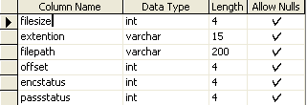

admin
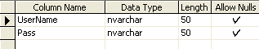

Data flow Diagram

Level 0

Select file
User
Login process
login
Add file

Level 1

Set password
User
Select file
Encryption
Store process
Store data

Level 2

User
Select file
Decryption
View file

ER new
decoding
view file
M
User
Login
Process
datatable
encoding
uname
pwd
enstatus
ext
fsize
1
1
M
M
1

SYSTEM TESTING AND MAINTENANCE

The most important phase in system development life cycle is system testing. The number and nature of errors in a newly designed system depends on the system specifications and the time frame given for the design.

A newly designed system should have all the subsystems working together, but in reality each subsystems work independently. During this phase, all the subsystems are gathered into one pool and tested to determine whether it meets the user requirements.

Testing is done at two level -Testing of individual modules and testing the entire system. During the system testing, the system is used experimentally to ensure that the software will run according to the specifications and in the way the user expects. Each test case is designed with the intent of finding errors in the way the system will process it.

Testing plays a very critical role in determining the reliability and efficiency of software and hence is a very important stage in software development. Software testing is done at different levels. They are the unit testing and system testing which comprises of integration testing and acceptance testing.

  - Unit Testing
  - System Testing
  - Integration Testing
  - Acceptance Testing

UNIT TESTING:

This is the first level of testing. The different modules are tested against the specifications produced during the integration. This is done to test the internal logic of each module. Those resulting from the interaction between modules are initially avoided. The input received and output generated is also tested to see whether it falls in the expected range of values. Unit testing is performed from the bottom up, starting with the smallest and lowest modules and proceeding one at a time.

The units in a system are the modules and routines that are assembled and integrated to perform a specific function. The programs are tested for correctness of logic applied and detection of errors in coding. Each of the modules was tested and errors are rectified. They were then found to function properly.

SYSTEM TESTING:

The integration of each module in the system is checked during this level of testing. The objective of system testing is to check if the software meets its requirements. System testing is done to uncover errors that were not found in earlier tests. This includes forced system failures and validation of total system as the user in the operational environment implements it. Under this testing, low volumes of transactions are generally based on live data. This volume is increased until the maximum level for each transactions type is reached. The total system is also tested for recovery after various major failures to ensure that no data are lost during the breakdown.

INTEGRATION TESTING:

In integration testing, the tested modules are combined into sub-systems, which are then tested. The goal of integration testing to check whether the modules can be integrated properly emphasizing on the interfaces between modules.
The different modules were linked together and integration testing done on them.

ACCEPTANCE TESTING:

The objective of the acceptance test is to tell the user about the validity and reliability of the system. It verifies whether the system operates as specified and the integrity of important data is maintained. User motivation is very important for the successful performance of the system.

All the modules were tested individually using both test data and live data. After each module was ascertained that it was working correctly and it had been "integrated" with the system. Again the system was tested as a whole. We hold the system tested with different types of users. The System Design, Data Flow Diagrams, procedures etc. were well documented so that the system can be easily maintained and upgraded by any computer professional at a later

Acceptance testing is done with live data provided by the client to ensure that the software works satisfactorily. This test focuses on the external behavior of the system. Data was entered and acceptance testing was performed.

SYSTEM IMPLEMENTATION

Implementation is the stage of the project when the theoretical design is turned out into a working system. Thus it can be considered to be the most critical stage in achieving a successful new system and in giving the user, confidence that the new system will work and be effective.

The implementation stage involves careful planning, investigation of the existing system and it’s constraints on implementation, designing of methods to achieve changeover and evaluation of changeover methods.

Implementation is the process of converting a new system design into operation. It is the phase that focuses on user training, site preparation and file conversion for installing a candidate system. The important factor that should be considered here is that the conversion should not disrupt the functioning of the organization.

CONCLUSION
It is concluded that the application works well and satisfy the needs. The application is tested very well and errors are properly debugged. It also acts as the sharing of network files to the valuable resources. This system is user friendly so everyone can use easily. Proper documentation is provided. The end user can easily understand how the whole system is implemented by going through the documentation. The system is tested, implemented and the performance is found to be satisfactory. All necessary output is generated. Thus, the project is completed successfully.

FUTURE AND ENHANCEMENT
There is scope for future development of this project. The world of computer fields is not static; it is always subject to be dynamic. The technology which is famous today becomes outdated the very next day. To keep abstract of technical improvements, the system may be further refined. So, it is not concluded. Yet it will improve with further enhancements.
Enhancements can be done in an efficient manner. We can even update the same with further modification establishment and can be integrated with minimal modification. Thus the project is flexible and can be enhanced at anytime with more advanced features.

BIBLIOGRAPHY

Books:

- Alistair McMonnies, “Object-oriented programming in Visual Basic.NET”, Pearson Education, and ISBN: 81-297-0649-0, First Indian Reprint 2004.

- Jittery R.Shapiro, “The Complete Reference Visual Basic .NET” Edition 2002, Tata McGraw-Hill, Publishing Company Limited, New Delhi.

- Robert D.Schneider, Jettey R.Garbus, “Optimizing SQL Server”, Second Edition, Pearson Education Asia, ISBN: 981-4035-20-3

Websites:

- http://www.microsoft.com/dotnet/visual basic
- http://www.dotnetheaven.com
- http://www.apache.org
- http://www.w3schools.com

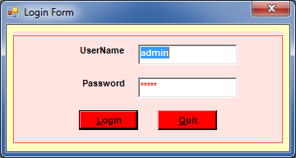

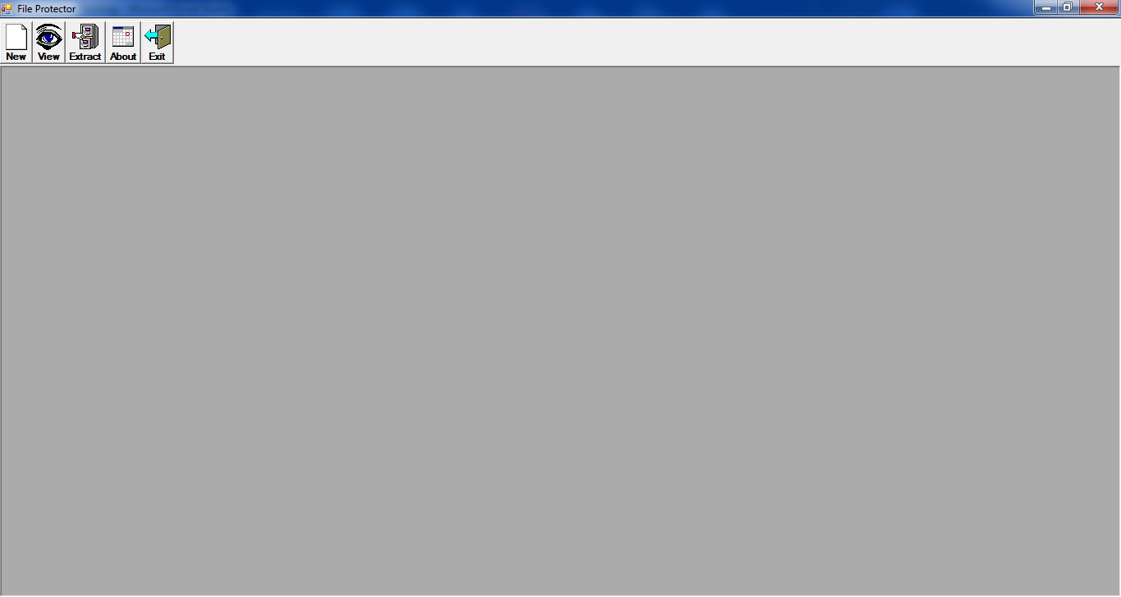

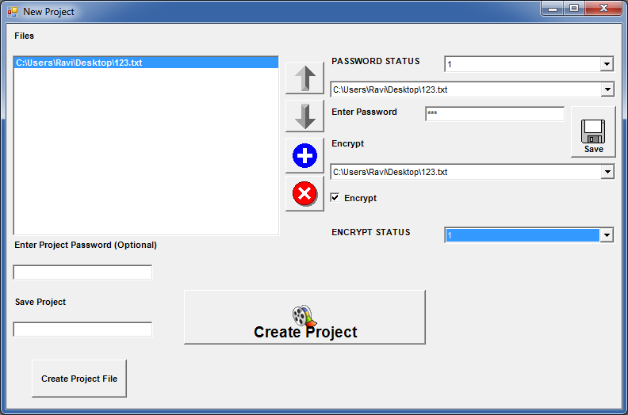

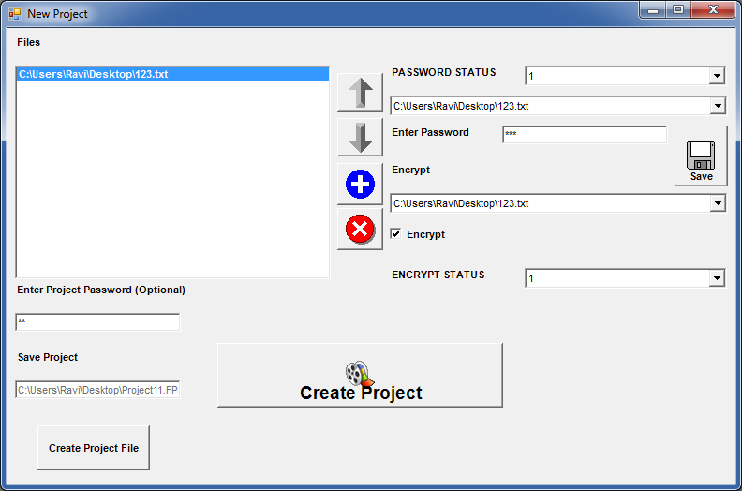

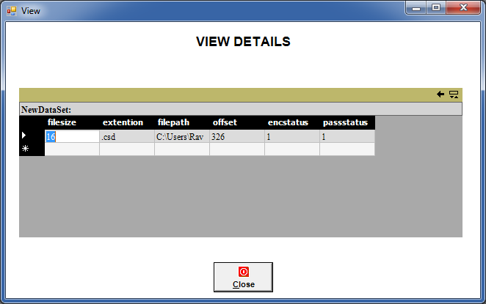

Sample Coding
Add Project

Dim PH As ProjectHeader
Dim FH() As FileHeader
'Dim Enc() As Boolean
'Dim Pass() As Boolean
'Dim PassText() As String
Dim si As Short

Private Sub Check1_CheckStateChanged(ByVal eventSender As System.Object, ByVal eventArgs As System.EventArgs) Handles Check1.CheckStateChanged
If Check1.CheckState = System.Windows.Forms.CheckState.Checked Then
'Combo2.ItemData(Combo2.ListIndex) = 1
VB6.SetItemString(Combo4, Combo2.SelectedIndex, "1")
Else
'Combo2.ItemData(Combo2.ListIndex) = 0
VB6.SetItemString(Combo4, Combo2.SelectedIndex, "0")
End If
End Sub

Private Sub Combo1_SelectedIndexChanged(ByVal eventSender As System.Object, ByVal eventArgs As System.EventArgs) Handles Combo1.SelectedIndexChanged
Text1.Text = VB6.GetItemString(Combo3, Combo1.SelectedIndex)
End Sub

Private Sub Combo2_SelectedIndexChanged(ByVal eventSender As System.Object, ByVal eventArgs As System.EventArgs) Handles Combo2.SelectedIndexChanged
If VB6.GetItemString(Combo4, Combo2.SelectedIndex) = "1" Then
Check1.CheckState = System.Windows.Forms.CheckState.Checked
Else
Check1.CheckState = System.Windows.Forms.CheckState.Unchecked
End If
End Sub

Private Sub Command1_Click(ByVal eventSender As System.Object, ByVal eventArgs As System.EventArgs) Handles Command1.Click
ChangeOrder(List1, -1)
ChangeOrder(Combo1, -1)
ChangeOrder(Combo2, -1)
ChangeOrder(Combo3, -1)
ChangeOrder(Combo4, -1)
ChangeOrder(Combo5, -1)
End Sub
Private Sub Command2_Click(ByVal eventSender As System.Object, ByVal eventArgs As System.EventArgs) Handles Command2.Click
ChangeOrder(List1, 1)
ChangeOrder(Combo1, 1)
ChangeOrder(Combo2, 1)
ChangeOrder(Combo3, 1)
ChangeOrder(Combo4, 1)
ChangeOrder(Combo5, 1)
End Sub

Private Sub Command3_Click(ByVal eventSender As System.Object, ByVal eventArgs As System.EventArgs) Handles Command3.Click
Dim i As Object
CommonDialog1.Filter = "All Files (*.*)|*.*"
CommonDialog1.ShowOpen()
If CommonDialog1.FileName <> "" Then
For i = 0 To List1.Items.Count - 1
If VB6.GetItemString(List1, i) = CommonDialog1.FileName Then
MsgBox("Already Added", MsgBoxStyle.Information)
Exit Sub
End If
Next
List1.Items.Add(CommonDialog1.FileName)
Combo3.Items.Add("")
Combo4.Items.Add("")
Combo5.Items.Add("")
RefillComboBoxes()
'ReDim Preserve Enc(List1.ListCount - 1)
'ReDim Preserve Pass(List1.ListCount - 1)
'ReDim Preserve PassText(List1.ListCount - 1)
End If
End Sub

Private Sub Command4_Click(ByVal eventSender As System.Object, ByVal eventArgs As System.EventArgs) Handles Command4.Click
Dim i As Short
For i = 0 To List1.Items.Count - 1
If List1.GetSelected(i) Then
List1.Items.RemoveAt(i)
Combo3.Items.RemoveAt(i)
Combo4.Items.RemoveAt(i)
Combo5.Items.RemoveAt(i)
Exit For
End If
Next
RefillComboBoxes()
End Sub

Public Sub ChangeOrder(ByRef List1 As ListBox, ByVal mode As Short)
On Error GoTo down
Dim arr() As String
Dim i As Short
Dim x As String
Dim tmp As String
If si >= 0 Then

ReDim arr(List1.Items.Count - 1)

For i = 0 To List1.Items.Count - 1

arr(i) = VB6.GetItemString(List1, i)
Next

tmp = arr(si)

arr(si) = arr(si + mode)
arr(si + mode) = tmp
List1.Items(si) = arr(si)
List1.Items(si + mode) = arr(si + mode)
List1.SelectedIndex = si
'List1.Selected(si) = True
List1.Focus()
End If
down:
End Sub
Public Sub ChangeOrder(ByRef List1 As ComboBox, ByVal mode As Short)
On Error GoTo down
Dim arr() As String
Dim i As Short
Dim x As String
Dim tmp As String
If si >= 0 Then

ReDim arr(List1.Items.Count - 1)

For i = 0 To List1.Items.Count - 1

arr(i) = VB6.GetItemString(List1, i)
Next

tmp = arr(si)

arr(si) = arr(si + mode)
arr(si + mode) = tmp
List1.Items(si) = arr(si)
List1.Items(si + mode) = arr(si + mode)
List1.SelectedIndex = si
'List1.Selected(si) = True
List1.Focus()
End If
down:
End Sub

Private Sub Command5_Click(ByVal eventSender As System.Object, ByVal eventArgs As System.EventArgs) Handles Command5.Click
If Text1.Text = "" Then
VB6.SetItemString(Combo5, Combo1.SelectedIndex, "0")
VB6.SetItemString(Combo3, Combo1.SelectedIndex, "")
'MsgBox "Please Enter password"
'Text1.SetFocus
'Exit Sub
Else
VB6.SetItemString(Combo5, Combo1.SelectedIndex, "1")
VB6.SetItemString(Combo3, Combo1.SelectedIndex, Text1.Text)
End If
End Sub

Private Sub Command6_Click(ByVal eventSender As System.Object, ByVal eventArgs As System.EventArgs) Handles Command6.Click
Dim revext As String
Dim revfn As String
If List1.Items.Count = 0 Then
MsgBox("Please Select Files", MsgBoxStyle.Information)
Command1.Focus()
Exit Sub
End If

'On Error GoTo ErrInfo
If Text3.Text = "" Then
MsgBox("Please Select Project File Path")
Command7.Focus()
Exit Sub
End If
Me.Cursor = System.Windows.Forms.Cursors.WaitCursor
Label6.Text = "Processing..."
'Filling Project Header Informatin
PH.NumberOfFiles = List1.Items.Count
If Text2.Text = "" Then
PH.IsProjectPasswordFound = "0"
PH.Password = ""
Else
PH.IsProjectPasswordFound = "1"
PH.Password = Text2.Text
End If

Dim PWFound As Boolean
Dim i As Short
For i = 0 To Combo5.Items.Count - 1
If VB6.GetItemString(Combo5, i) = "1" Then
PWFound = True
Exit For
End If
Next
If Not PWFound Then
PH.IsNoFilePasswordProtected = "1"
Else
PH.IsNoFilePasswordProtected = "0"
End If

'Filling File Header Information
Dim fso As New Scripting.FileSystemObject
ReDim FH(List1.Items.Count - 1)
Dim fn As String
Dim fil As Scripting.File
For i = 0 To List1.Items.Count - 1
fn = VB6.GetItemString(List1, i)
fil = fso.GetFile(fn)
FH(i).FileSize = fil.Size ' FileLen(fn)
revfn = StrReverse(fn)
revext = Mid(revfn, 1, InStr(1, revfn, ".") - 1)

FH(i).FileExtension = StrReverse(revext)
FH(i).FilePath = fil.Path
' MsgBox(fil.Path)
If VB6.GetItemString(Combo5, i) = "1" Then
FH(i).IsPasswordProtected = "1"
FH(i).Password = VB6.GetItemString(Combo3, i)
Else
FH(i).IsPasswordProtected = "0"
FH(i).Password = ""
End If

If VB6.GetItemString(Combo4, i) = "1" Then
FH(i).IsEncrypted = "1"
Else
FH(i).IsEncrypted = "0"
End If
Next

Dim Offset As Double
'On Error GoTo ErrInfo
If fso.FileExists(Text3.Text) Then
fso.DeleteFile(Text3.Text, True)
End If
FileOpen(1, Text3.Text, OpenMode.Binary)

FilePut(1, PH)

For i = 0 To List1.Items.Count - 1
FH(i).FileOffSet = 26 + (List1.Items.Count * 300) + Offset
Offset = Offset + FH(i).FileSize
FilePut(1, FH(i))
Next

Dim ts As Scripting.TextStream

Dim c As String
For i = 0 To List1.Items.Count - 1
Label6.Text = "Saving " & VB6.GetItemString(List1, i)
If FH(i).IsEncrypted = "1" Then
EncFile("abcdefgh", VB6.GetItemString(List1, i), VB6.GetItemString(List1, i) & ".csd")
ts = fso.OpenTextFile(VB6.GetItemString(List1, i) & ".csd", Scripting.IOMode.ForReading, False)
fil = fso.GetFile(VB6.GetItemString(List1, i) & ".csd")
FH(i).FileExtension = ".csd"
FH(i).FileSize = fil.Size ' FileLen(fn)
Else
ts = fso.OpenTextFile(VB6.GetItemString(List1, i), Scripting.IOMode.ForReading, False)
fil = fso.GetFile(VB6.GetItemString(List1, i))
FH(i).FileSize = fil.Size ' FileLen(fn)
End If
Do While Not ts.AtEndOfStream
c = ts.Read(1)
FilePut(1, c)
Loop
ts.Close()
Next

Offset = 0
For i = 0 To List1.Items.Count - 1
FH(i).FileOffSet = 26 + List1.Items.Count * 300 + Offset
Offset = Offset + FH(i).FileSize
FilePut(1, FH(i), 27 + (i * 300))
Next
FileClose(1)
Label6.Text = "Finished..."
Me.Cursor = System.Windows.Forms.Cursors.Default
MsgBox("Project Created", MsgBoxStyle.Information)
ErrInfo:
If Err.Number <> 0 Then
MsgBox(Err.Description)
End If

End Sub

Private Sub Command7_Click(ByVal eventSender As System.Object, ByVal eventArgs As System.EventArgs) Handles Command7.Click
CommonDialog2.FileName = "C:\Project1.fpp"
CommonDialog2.ShowSave()
Dim fso As New Scripting.FileSystemObject
If CommonDialog2.FileName <> "" Then
If UCase(VB.Right(CommonDialog2.FileName, 4)) <> ".FPP" Then
Text3.Text = CommonDialog2.FileName & ".FPP"
Else
Text3.Text = CommonDialog2.FileName
End If
fso = Nothing
End If
End Sub

Private Sub Command8_Click(ByVal eventSender As System.Object, ByVal eventArgs As System.EventArgs) Handles Command8.Click
Dim k As Integer
Dim revext As String
Dim revfn As String
Dim i As Long
Dim fn As String
For i = 0 To List1.Items.Count - 1
If List1.GetSelected(i) = True Then
fn = List1.Text
Exit For
End If
Next
Dim pw As String
Dim j As Long
Dim c As String
Dim fso As New Scripting.FileSystemObject
If fn <> "" Then

If h(i).IsPasswordProtected = "1" Then 'IsProjectPasswordFound
pw = InputBox("Enter password")
If pw <> Trim(h(i).Password) Then 'ProjectPassword
MsgBox("Wrong Password")
Exit Sub
End If
End If

revfn = StrReverse(fn)
revext = Mid(revfn, 1, InStr(1, revfn, ".") - 1)
CommonDialog3.Filter = "Files |*." & StrReverse(revext) & ""
CommonDialog3.ShowSave()
If CommonDialog3.FileName <> "" Then
fn = Mid(fn, InStrRev(fn, "\") + 1)
FileOpen(1, Text3.Text, OpenMode.Binary)
For j = 1 To h(List1.SelectedIndex).FileOffSet
c = Space(1)
FileGet(1, c, j)

